8:23 pm

Dear Diary,

Some notes from today:

I miss Sam a lot. I’ve been texting him that:

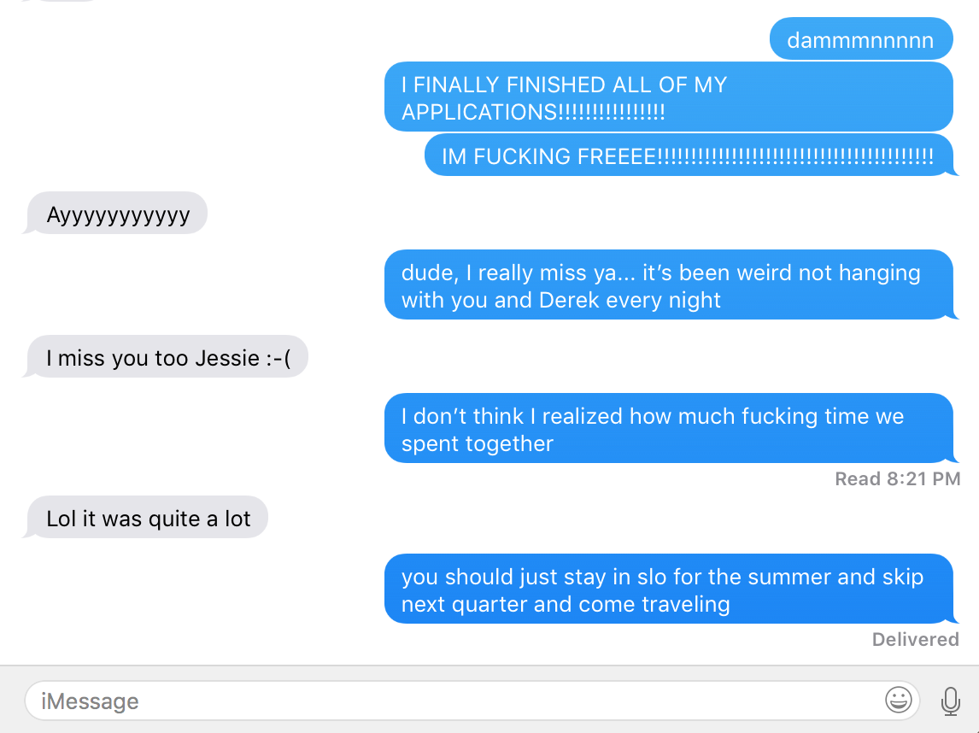

8:00 pm (earlier)

Try to be the bigger person more often.

(thought of this in regards to reverting back to younger self when home)

I feel like I can be rude or mean or not as grateful or helpful when I’m home sometimes so I’m trying to just be always nice generally while here. I have no more reason for stress… I FINISHED ALL OF MY GRAD APPS TODAY!!! I still need to send off the USI one but I’m waiting to hear back some stuff before I email it all in. I have all the app stuff ready to go though! I’m so fucking excited to see what happens.

I’m really not expecting to get into much, and the great thing is that I actually will be happy regardless of the outcome.

Here’s why:

\*\* Grabs Burrito \*\*

\*\* Tries Burrito \*\*

One Sec.

\*\* Nukes Burrito (microwaves) \*\*

Okay, here’s why:

\*\* ½ a burrito, 2 small bowls of icecream, and like 3 youtube videos later… \*\*

Anyways, the reason I will be happy regardless of the outcome is because I honestly would love to do a lot of different things in the future. If I get into one of my dream programs, then I will 100% go to them and be so stoked. If I don’t, then I have the option to go Switzerland already, or if I find funding I already have the option to go to Ireland. The great thing is that both of those opportunities can be just a year if I want them to be.

BUT, if I either somehow have all of my graduate school opportunities fall through, I’d be happy going and living with Sam and Yeng and working for somewhere in SF and living with them for a few years. Or going to Venice Beach and Santa Monica and living around Wesley and Claudia for a little while. I could see myself in a lot of places in a lot of positions. Maybe I’ll join the Peace Corps after all.

Either way, the point I’m getting at is that I am going to be happy with any of the scenarios I could end up in at this time next year. I think it’s actually pretty crazy that this is the least I’ve ever known about where I’ll be in a year in advance. Especially in terms of geographical distance from where I am right now.

I’m So Fucking Excited.

6 days until Thailand.